Student name: Student ID#:

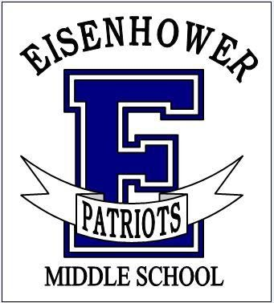
Students will automatically be placed into the next English and Math course in the sequence, History 8, PE Foundational 8. For more information on course sequencing, see page 15 in the MS Course Catalog.

All students are required to take the core courses listed below.

Students will choose 3 semesters of electives.
See back side for elective options.
Subject | Semester | Course Choices
Required Courses
English | Year long | English 8  Pre-AP English 1* (1.0 HS credit course)
Mathematics | Year long | Math 8  Algebraic Concepts* (1.0 HS credit course)  Geometry in Application* (1.0 HS credit course)
Science | Year long | Science 8 or Coordinated Science* (1.0 HS credit course)
Social Studies | Year long | History 8
Physical Education | One semester | Physical Education – Foundational 8

Advanced Pathway Courses:
*Students wanting to move from English 7 into Pre-AP English 1 need to complete an application form and return to Ms. Burdick in the counseling office by March 28th. Placement is based on grades, SBA scores and teacher recommendation. Space is limited.

*Students wanting to move into the Accelerated Math track will be required to complete a summer school math course.

ELECTIVE COURSES
Choose 1 Elective Path
OR

Elective Courses – Performing Arts Path
Performing Arts | Year long | Band 3  Choir 2  Intermezzo Orchestra
Elective Courses – Non-Performing Arts Path
If you DID NOT choose a Performing Arts, select 3 electives below.
One semester of a Performing/Visual Arts is required.
Performing/ Visual Arts | One semester | Art 8  Yearbook  Exploring Graphic Arts*
Physical Education  Electives | One semester | Lifetime PE  Team Sports
STEM Electives  STEM/Arts | One semester | - Robotics Tech I  - Robotics Tech II  - Integrated Technology 1  - Integrated Technology 2  - Digital Manufacturing (CAD)*  - Exploring Graphic Arts*
Other Electives | Yearlong | - Spanish 1*
In addition to your Performing Arts course, select 1 additional elective.

Performing/ Visual Arts | One semester | Art 8  Yearbook  Exploring Graphic Arts*
Physical Education  Electives | One semester | Lifetime PE  Team Sports
STEM Electives  STEM/Arts | One semester | - Robotics Tech I  - Robotics Tech II  - Integrated Technology 1  - Integrated Technology 2  - Digital Manufacturing (CAD)*  - Exploring Graphic Arts*
Other Electives | Yearlong | - Spanish 1*

Important: Every attempt is made to schedule students in their chosen classes. However, students may be placed in alternates or other classes due to class sizes and/or scheduling conflicts.
*Elective courses for HS Credit:
Digital Manufacturing (CAD) and Exploring Graphic Arts
Error in the MS Catalog: Robotics Tech 1 is NOT a HS credit course.
Elective Alternates
Please select Alternates to your elective choices:
List Your 1st choice Electives |  | Write your Alternate for this class

You must enter “Alternates” for all electives other than Performing Arts. Band, Choir and Orchestra do not need alternates.
“Alternates” are your second choice.

